Research Project
On
“Exploring the satisfaction of using Mobile Banking among students at University of Rajshahi”



A Research Project Submitted to the Department of Statistics, University of Rajshahi, Rajshahi-6205, Bangladesh, in Partial Fulfillment of the Requirements for the Degree of Bachelor of Science (B.Sc.) in Statistics

Submitted by
Examination Roll No: 2010924181
Registration No: 2010924181
Session: 2019-2020
Examination Year: 2023
Date of Submission: 24 November, 2024

Department of Statistics, University of Rajshahi
Rajshahi-6205, Bangladesh

Dedicated to
My Beloved Parents and Supervisor

Acknowledgement

First and foremost, I convey my wholehearted gratitude to Almighty Allah for giving me the strength, patience, courage and endurance to complete my research study in time despite of all the troubles. There were many times that I called Almighty’s name to help, comfort and guidance.
I would like to express my sincere and heartiest gratitude to my reverend teacher and supervisor, Department of Statistics, University of Rajshahi, for introducing me to the research field. Completion of this project paper has been possible only by providing me with constant support, helpful guidance, thoughtful encouragement, suggestions and enlightened discussion during every phase of the study.
I also grateful to the chairman of the examination committee for providing me with sufficient time for completing this thesis paper.
I would like to express my gratitude to my beloved parents and family members for their love, affection, support, and encouragement which helped me in the completion of this study. My thanks and appreciation also go to my friends in developing the study and all the well-wishers who have willingly helped me out with their abilities.
In preparing for the research study, I was especially exposed to the real-life experience. I also felt it was a unique opportunity for me to learn about practical work. The research has improved my knowledge and attitude about the field to a large extent.
Finally, some drawbacks come with every human endeavor. I therefore request every reader of this thesis paper to furnish me if I do any mistake, so that further action for improvement can be taken.

The Author
Department of Statistics
University of Rajshahi

Abstract
The advent of information technology in the financial sector has given banking services a new dimension in the twenty-first century. The widespread adoption of mobile banking has transformed how customers interact with financial institutions, emphasizing the need to understand and measure user satisfaction effectively. This project aims to develop a comprehensive framework for assessing customer satisfaction with mobile banking services. A cross-sectional study was conducted between 250 respondents of University of Rajshahi. Samples were collected by two-stage sampling. Descriptive statistics, Chi-square test and logistic regression were used to determine the satisfaction level of mobile banking among the students in University of Rajshahi. In this study, we observed that there were 77.60% male, 22.40% female, 60.40% rural, 39.60% urban, 87.6% muslim, 11.6% hindu, 0.8% from other religion, 87.60% undergraduate, 12.40% graduate, 18.4% arts,32.4% science, 4.0% law,19.2% business studies, 8.4% social science, 2% agriculture, 9.2% engineering, 3.6% biological sciences, 1.6% veterinary and animal science,1.2% geosciences students respectively. From chi-square test, we did not find any significant association between parental occupation and satisfaction level with overall mobile banking experience. We found that there was a significant association between academic level, frequency of use of mobile banking, confidence level on security, experience about customer care support, speed of transaction and satisfaction level with overall mobile banking experience and all variables are insignificant. In binary logistic regression analysis, Hosmer and Lemeshow test showed that our selected model was good fitted. Among 250 students in University of Rajshahi, 147 (58.80%) students reported being satisfied with their overall banking experience and 103 (41.20%) students indicated dissatisfaction with their mobile banking experience.

Table of Contents
Acknowledgement i
Abstract ii
CHAPTER 1: Introduction ………………………………………...…………1
1.1 Background of the study 1
1.2 Importance of the study 2
1.3 Objective of the study 2
1.4 Research question 3
1.5 Organization of the study 3
CHAPTER 2: Review of Literature ……………………………………..…...4
2.1 Introduction 4
2.2 Review of relevant literature 4
2.3 Research gap 6
CHAPTER 3: Materials and Methods ………………………..……….……..7
3.1 Study area and population 7
3.2 Type of study 8
3.3 Sample size determination 8
3.4 Sampling procedure 8
3.5 Questionnaire development 9
3.6 Outcome variable 10
3.7 Independent variable 10
3.8 Statistical analysis 10
3.8.1 Preliminary data analysis 10
3.8.2 Analysis of association 11
3.8.3 Binary logistics regression analysis 11
CHAPTER 4: Results and Discussion …………………………………...….14
4.1 Preliminary data analysis 14
4.2 Association analysis 24
4.3 Binary logistic regression analysis 30
CHAPTER 5: Conclusion ………………………………..………………….33
5.1 Conclusion 33
5.2 Limitation 33
5.3 Recommendation 34
Bibliography 35
Questionnaire for Research Project 36

CHAPTER 1

Introduction

1.1 Background of the study
The rapid growth of mobile banking is reshaping the financial services landscape, driven by technological advancements and increasing smartphone penetration. Mobile banking allows customers to conduct financial transactions conveniently, offering services such as fund transfers, bill payments, and real-time account monitoring. This shift from traditional banking methods to digital platforms has made customer satisfaction a critical factor for banks to retain and expand their user base. Customer satisfaction in mobile banking hinges on several key factors, including security, ease of use, transaction speed, and accessibility. Research shows that features like cost efficiency and adaptability to user preferences significantly influence satisfaction levels(Kameswaran & Muralidhar, 2019).
Cross-cultural studies have revealed that customer expectations and satisfaction vary based on cultural and regional contexts. For example, perceived justice in addressing service failures plays a significant role in shaping customer loyalty and trust in mobile banking apps (Santini et al., 2020). Demographic factors, such as age and education, also impact the adoption and satisfaction rates of mobile banking users (Al-Husein & Sadi, 2015). Despite the advantages, mobile banking faces challenges, including user concerns about privacy, technical glitches, and resistance to change. Addressing these challenges through effective service design and customer support is vital for banks to remain competitive in the digital era.
This study basically focuses on students of University of Rajshahi, and tries to measure their satisfaction level, evaluate their choices, preference and considerable factors for mobile banking adoption and retention. By understanding the factors that drive customer satisfaction, banks can enhance the mobile banking experience, fostering trust and long-term customer relationships. This study seeks to explore these dimensions, providing actionable insights for improving mobile banking services.

1.2 Importance of the study
The importance of studying student satisfaction with mobile banking services at University of Rajshahi can shed light on the unique experiences and challenges students face with mobile financial solutions. It includes:
- Enhancing Mobile Banking Adoption: Helps financial institutions understand what drives student satisfaction, fostering wider adoption and digital financial inclusion.

- Improving Service Quality: Provides information that banks can utilize to customize mobile banking offerings to the tastes of students, improving customer satisfaction and loyalty.
- Promoting Financial Literacy: Aids students in cultivating financial independence and literacy, as many are inexperienced in financial management.
- Identifying Accessibility Barriers: Reflects the potential obstacles students encounter with mobile banking, facilitating more inclusive services.
- Enhancing Academic Research: Contributes to the literature of youth satisfaction with mobile banking, especially in South Asia.
- Guiding Policy and Service Innovation: The results of the study can help shape banking regulations and stimulate innovations in mobile banking that put the requirements of students first in areas like customer service, security, and user interface.
- Encouraging Financial Independence: Mobile banking can be customized to assist students in their attempt for financial independence by taking into account their demands and promoting appropriate banking practices.

1.3 Objective of the study
On the basis of our research questions, the main objective of the study is to investigate students’ satisfaction with mobile banking services at University of Rajshahi.
The specific objectives of the study are mentioned below:
- Assess students' satisfaction levels with the use of mobile banking at Rajshahi University.
- Identify key factors influencing satisfaction (e.g., usability, security, transaction speed).
- Recommend ways to enhance mobile banking experiences for students.
- To gather insights on any additional features or innovative solutions that students would like to see integrated into mobile banking apps.

1.4 Research question
The key research questions of this study are given below:
- How satisfied are students at University of Rajshahi with mobile banking overall?
- Which factors are most important in shaping student satisfaction?
- Are there common issues students face with mobile banking services?
- How often do students use mobile banking services?
- How well does mobile banking app meet students’ expectations in terms of speed and reliability of transactions?

1.5 Organization of the study
The study consists of five chapters which are:
Chapter 1: Introduction
Chapter 2: Review of Literature
Chapter 3: Materials and Methods
Chapter 4: Results and Discussion
Chapter 5: Conclusion

CHAPTER 2

Review of Literature

2.1 Introduction
A literature review is significant mainly to (i). find out the knowledge gap of the study, (ii). clarify the conceptual framework or building a theoretical framework, (iii). identify the source of knowledge, information, and data from the secondary source, and (iv). justify the field or topic of the study. The review of literature for a research program is essential. Consequently, several books, journals, and published and unpublished theses have been reviewed to find the knowledge gap in this study along with the websites some other relevant materials have also been critically reviewed to find out the knowledge gap in this study topic and for fulfilling the other relevant requirement of the proposed study.

2.2 Review of relevant literature
As mobile usage has increased dramatically, mobile banking has grown in popularity and familiarity. Bankers are also interested in maintaining the value-added services offered by mobile banking while adding new features. As a result, mobile banking is currently a significant study topic.
According to (Singh, 2012), mobile banking represents an evolutionary milestone in the banking sector, enabling financial institutions to collaborate with mobile operators to deliver a wide range of services across diverse business domains. This integration allows banks to extend their reach, particularly in rural and underbanked areas, offering services such as account management, fund transfers, and bill payments. The collaboration between banks and mobile operators leverages advanced technologies to enhance customer convenience and accessibility. This partnership not only modernizes traditional banking practices but also fosters innovation by addressing customer needs in real time. Singh emphasized that such advancements are essential for keeping pace with global trends and ensuring a competitive edge in the financial sector.
(Dahlberg et al., 2015) conducted a critical review of mobile payment research, analyzing its progression over the previous decade. The study focused on key themes such as consumer adoption, technology integration, and trust in mobile payment systems. It identified a lack of diversity in research topics, with most studies concentrating on similar findings. The authors proposed a new research agenda to explore unaddressed areas and enhance the understanding of mobile payments in practice.
Like many other countries, in Bangladesh mobile banking is now very popular and also gaining more popularity day by day. In Bangladesh, there also has some study about mobile banking. To determine the elements that affect mobile banking usage in developing nations, (Kabir, 2013) discussed various factors influencing mobile banking adoption, including trust, convenience, relative advantage, perceived costs, and time savings. It emphasizes that trust, which involves the perceived ability, integrity, and benevolence of service providers, plays a critical role in user adoption. Moreover, convenience, such as ease of access and reduced effort, combined with relative advantages over traditional banking channels, significantly affect customer behavior. Perceived cost savings and time efficiency also emerge as strong motivators for mobile banking users.
(Islam et al., 2019) explored the factors that influence the adoption and continued use of mobile banking services. Key drivers included trust, perceived ease of use, security, and cost. The study emphasized that perceived trustworthiness is critical for adoption, especially in developing economies. Customers are more likely to adopt mobile banking when they perceive it as secure and reliable, addressing risks related to data loss and privacy.The research also highlighted that satisfaction, driven by the confirmation of expectations and perceived usefulness, played a central role in ensuring the continued use of mobile banking platforms. These findings align with extended theoretical models like the Technology Continuance Theory (TCT), which focuses on post-adoption behavior and retention.
With all of these considerations, (Hai & Rahman, 2016) focused on the overall satisfaction levels of mobile financial service users, particularly in the context of Bangladesh. Their study revealed that while mobile banking has become increasingly popular, key factors like service quality, reliability, and responsiveness significantly impact customer satisfaction. They highlighted the importance of mobile banking platforms in fostering financial inclusion, especially in regions underserved by traditional banking services. Their research suggested that improving the tangibility (infrastructure and interface quality) and responsiveness of services could enhance customer experiences. Moreover, cultural and economic contexts played a pivotal role in shaping user perceptions and trust in mobile financial services​.
(Shaikh & Karjaluoto, 2015) conducted a study on mobile banking adoption, emphasizing its significant role in enhancing banking services, particularly in developing countries. They discussed how mobile banking serves as a critical alternative delivery channel for financial transactions, offering benefits like increased access to banking services for previously unbanked populations, improved customer retention, and operational efficiency. Despite these advantages, the authors highlighted that mobile banking's adoption is not as widespread as expected, with barriers such as security concerns and technological limitations hindering its broader use. Their research suggested that further investigation into adoption drivers and persistent barriers is crucial for optimizing mobile banking services.
Despite its benefits, mobile banking poses certain challenges, particularly for students. (Zhou et al., 2010) indicate that students place a high value on ease of use and rapid service delivery, more so than older demographics, who may prioritize security features. This demographic-specific research underscores the need for mobile banking services to adapt to the distinct preferences and expectations of student users, who are generally more tech-savvy yet budget-conscious.

2.3 Research gap
After doing the above-mentioned literature review, we found some research gap which are pointed below:
- Limited research on mobile banking satisfaction specifically among students.
- Only a few studies focused on mobile banking in the South Asian context.
- Student-specific needs like ease of use, cost sensitivity, and quick support are underexplored.
- Limited examination of the impact of mobile banking on students' financial literacy.

CHAPTER 3

Materials and Methods

3.1 Study area and population
This study is being carried out on students at Rajshahi University. The University of Rajshahi, also called Rajshahi University or RU, is a public, coeducational research university in Bangladesh that is located close to the city of Rajshahi in the north. It has a 305-hectare (753-acre) campus at Motihar, which is 3 kilometers (2 miles) east of the city center. It is the second-oldest university in Bangladesh and the second-largest in terms of campus size and academic activities. It is regarded as one of Bangladesh's best research universities. Recent efforts by this university's researchers have been crucial in reviving the traditional Bangladeshi muslin fabric. It has a formidable alumnus base around Bangladesh and abroad. It is popularly known as the Cambridge of the East. Rajshahi University currently has 12 faculties: Arts, Science, Fine Arts, Law, Engineering, Social Science, Business Studies, Agriculture, Geosciences, Veterinary & Animal Sciences and Fisheries. Every faculty member is then divided into many departments (59). There are several students in each department. I used students randomly from almost every faculty for my project survey.

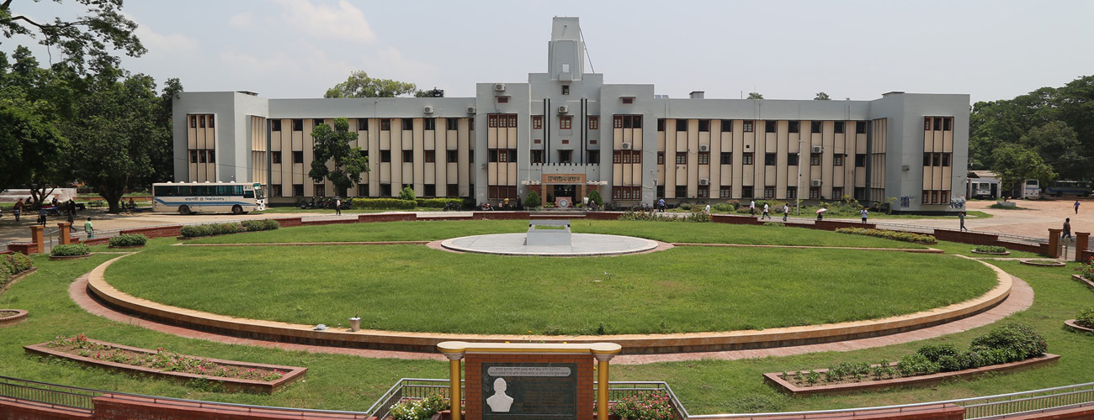
Fig-3.1.1: University of Rajshahi Campus

3.2 Type of study
For this project survey, the type of the study was a cross-sectional study i.e., we collected data from many different individuals at a single point of time.
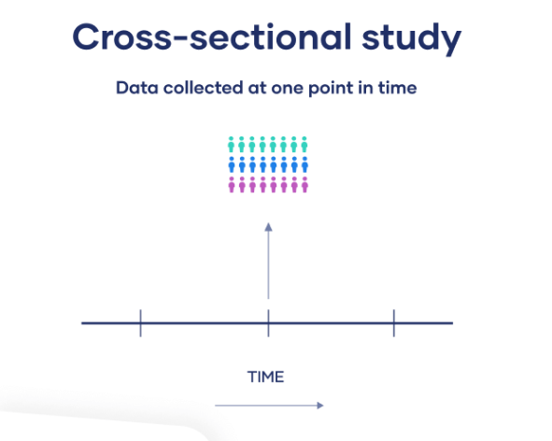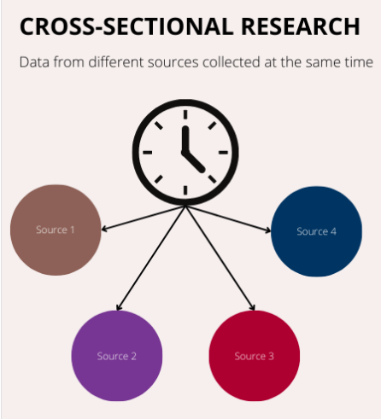
Fig-3.2.1: Cross-sectional research study

3.3 Sample size determination
Sample size determination is the act of choosing the number of observations or replicates to include in a statistical sample. The required sample size for this study was determined using the formula given by Cochran. The sample size formula is
$n=\frac{z^{2}p(1-p)}{d^{2}}=\frac{{(1.96}^{2}).\left(0.2\right).(1-0.2)}{{0.05}^{2}}=246$; for two tailed tests corresponding to 95% confidence interval at 5% level of significance.
Here we considered, p = 0.2 (Akter, 2023) and d = 0.05 (margin of error)
This formula provided that 246 samples was required for this study. However, the study considered 250 samples for getting accurate results.

3.4 Sampling procedure
For our study, we used two-stage sampling techniques to select 250 samples from the population. In the first stage, we selected four halls (three male halls and one female hall) out of seventeen halls of University of Rajshahi using simple random sampling. Then, in the second stage, students from each hall were selected using convenience sampling. Before collecting the data, the objective of our study was discussed with all the selected students. We have visited different halls of University of Rajshahi to collect the necessary data. Data was collected using self-developed pre-tested structured questionnaire. The questionnaire comprised two segments: A. Personal details and B. Banking information. When collecting data, we discussed our research with the selected participants and obtained written consent from each.
Here, we used two stages for collection of samples.
17 Halls of RU

Mannujan Hall
Shahid Shamsuzzoha Hall
Nawab Abdul Latif Hall
Shah Makhdum Hall

Undergraduate and Graduate students

Fig-3.4.1: Sampling Procedure

3.5 Questionnaire development
(i). Determine the survey objectives, resources and time constraints.
(ii). Determine the question format.
(iii). Writing clear questions.
(iv). Designing the question flow.
(v). Questionnaire evaluation.
(vi). Prepare final questionnaire, copy and layout.
(vii). Field questionnaire.

3.6 Outcome variable
A variable that is thoroughly investigated or evaluated in a research study is called an outcome variable, sometimes known as a dependent variable. In order to assess the impacts, influences, or modifications resulting from one or more independent variables, researchers measure, observe, or document this variable. The satisfaction level of overall experience with mobile banking was the outcome variable of this study. We categorized the outcome variable by asking, “Do you satisfied with your overall experience with mobile banking?” Option (i) Yes codded “1” (ii) No codded “0”.

3.7 Independent variable
In a study, the independent variable is the cause that can affect the results. It is not influenced by other variables and can vary from person to person or place to place. In this study, there are several independent variables including: academic level, frequency of use of mobile banking, confidence level in mobile banking transactions, experience on customer care support, and speed of transaction in mobile banking.

3.8 Statistical analysis
To meet the objectives of the study, some statistical techniques were used which include preliminary data analysis (frequency distribution and graphical presentation), analysis of association (chi-square test) and binary logistic regression analysis.
Software: The statistical analysis was carried out using SPSS software (version 26). The operating system of the computer was Windows 11 and text and tables were prepared by MS word. A p-value <0.05 was considered as statistically significant in this analysis.

3.8.1 Preliminary data analysis
To investigate the patterns of different variables, percentage (frequency) distribution of the selected explanatory variables was computed and some of the variables was illustrated graphically.

3.8.2 Analysis of association
The chi-square (χ2) test was employed to find the significant association between different independent variables and outcome variable.
A chi-square test or comparable nonparametric test is required to test a hypothesis regarding the distribution of a categorical variable. By the chi-square test we have shown the association between the dependent variable and independent variables by the cross tables. The formula is,
$$χ^{2}=\sum_{i}{\frac{{\left(O_{i}-E_{i}\right)}^{2}}{E_{i}}\sim }χ_{(n-1)(k-1)}^{2}$$
Where, O_{i} = Observed value (actual value), E_{i} = Expected value, n is the total number of rows and k is the total number of columns
And we have to test the following statistical hypothesis:
H₀: There is no significant association between independent variables and dependent variables.
H₁: H₀ is not true.

3.8.3 Binary logistics regression analysis
Regression analysis is a set of statistical methods used for the estimation of relationships between a dependent variable and one or more independent variables. Binary logistic regression is a regression model where the target (dependent) variable is binary (two categories), that is, it can take only two values, 0 or 1.

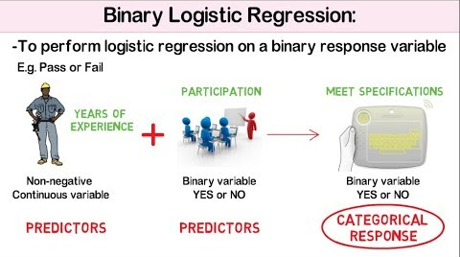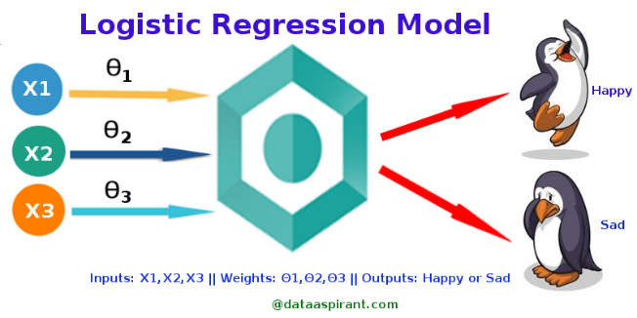
Not only does binary logistic regression allow us to assess how well our set of variables predicts our categorical dependent variable and determine the "goodness of fit" of our model as does regular linear regression, but also it provides a summary of the accuracy of the classification of cases, which helps us determine the percent of predictions made from this model / equation that will be corrected. The model was
$$Y\left(Yes=1;No=0\right)=\log\left(\frac{P}{1-P}\right)=β_{0}+β_{1}X_{1}+β_{2}X_{2}+β_{3}X_{3}+β_{4}X_{4}+β_{5}X_{5}+ε_{j}$$
Where, Y = Satisfaction level with mobile banking (Yes=1, No=0), X₁= Academic level, X₂= Frequency of uses of mobile banking, X₃= Confidence level on security, X₄= Experience with customer care support, X₅= Speed of transaction, $β_{0}$= intercept term, $β_{j}$’s (j=1,2,3,4,5) are regression coefficients and $ε_{j}$= random error.
We have to test the following hypothesis:
H₀: $β_{j}=0$ or OR=1; where j=1,2,3,4,5
H₁: H₀ is not true.
Where, OR (odds ratio) =$e^{β_{j}}$ =$e^{0}=1$
If the regression coefficient is positive, non-reference case is more likely to get Yes for outcome variable; on the other hand, if regression coefficient is negative, non-reference case is less likely to get Yes for outcome variable. The OR is useful for comparing non-reference group to reference getting time (how many time) more or less to get Yes case.

We have used Hosmer and Lemeshow test to test the goodness of fit. Here we have the following hypothesis:
H₀: The observed and model-predicted values are the same.
H₁: H₀ is not true.
We also used receiver operating characteristic (ROC) curve which shows that how well our binary classifier model performs at different threshold values. It plots the true positive rate (TPR) against the false positive rate (FPR) at each threshold setting.

CHAPTER 4

Results and Discussion

4.1 Preliminary data analysis
Descriptive statistics summarizes the characteristics of a data set consisting measurements of central tendency (e.g., mean, median, mode), measurements of variability or spread (e.g., variance, standard deviation, coefficient of variation), and frequency distribution comprise its three fundamental categories of measures.
Table 4.1.1 represents the summary statistics of the variables ‘Age (in years)’, ‘Family income (in taka)’, ‘Personal income (in taka)’ and ‘Monthly expenditure (in taka)’. Here, we observed that the coefficient of variation of ‘Personal income’ is more and ‘Age’ is less among four variables. The distribution of all the four variables is positively skewed and platykurtic for ‘Age’ whereas leptokurtic for the rest of three variables.
Table 4.1.1: Summary statistics for the variables Age, Family income, Personal income, Monthly expenditure of the students.
Statistics | Age  (in years) | Family income  (in taka) | Personal income  (in taka) | Monthly expenditure (in taka)
Minimum | 19 | 2000 | 1000 | 2000
Maximum | 28 | 100000 | 30000 | 17000
Mean | 22.74 | 22818.80 | 5231.18 | 5663.20
Median | 23 | 20000 | 4000 | 5000
Standard deviation | 1.563 | 16088.421 | 4153.678 | 1993.243
Coefficient of variation | 6.873 | 70.505 | 79.402 | 35.196
Skewness | 0.560 | 1.721 | 3.348 | 1.935
Kurtosis | 0.574 | 4.212 | 15.063 | 6.258

Table-4.1.2 shows there are 219 muslim students with 87.6%,29 hindu students with 11.6% and 2 others with 0.8% out of 250 students in University of Rajshahi. As Bangladesh is a muslim country, most of the students are muslim in this University.

Table-4.1.2: Frequency distribution of religion of the students
Religion | Frequency | Percent frequency
Muslim | 219 | 87.6
Hindu | 29 | 11.6
Others | 2 | 0.8
Total | 250 | 100.0

Table-4.1.3 shows that there are 46 students with 18.4%,81 students with 32.4%,10 students with 4.0%,48 students with 19.2%,21 students with 8.4%,5 students with 2.0%,23 students with 9.2%,9 students with 3.6%,4 students with 1.6%,3 students with 1.2% from arts, science, law, business studies, social science, agriculture, engineering, biological sciences, veterinary and animal science and geosciences faculties respectively.
Table-4.1.3: Frequency distribution of faculty of the students
Faculty | Frequency | Percent frequency
Arts | 46 | 18.4
Science | 81 | 32.4
Law | 10 | 4.0
Business studies | 48 | 19.2
Social science | 21 | 8.4
Agriculture | 5 | 2.0
Engineering | 23 | 9.2
Biological sciences | 9 | 3.6
Veterinary & animal science | 4 | 1.6
Geosciences | 3 | 1.2
Total | 250 | 100.0

From Table-4.1.4 we observed that most of the mothers of the students are homemaker which is 218 with 87.2%,15 mothers with 6.0% are teachers,3 mothers with 1.2% are health professionals,4 mothers with 1.6% are from other services and rest 10 mothers with4.0% are from others category among 250 mothers of the students.

Table-4.1.4: Frequency distribution of occupation of student’s mother
Occupation | Frequency | Percent frequency
Homemaker | 218 | 87.2
Teacher | 15 | 6.0
Health professional | 3 | 1.2
Other services | 4 | 1.6
Others | 10 | 4.0
Total | 250 | 100.0

We have observed that 93 students have their own income source among the 250 students. Table-4.1.5 shows that most the students have tuition as their income source which is 76 with 81.7%. There are 3 students with 3.2%,5 students with 5.4%, 3 students with 3.2% and 6 students with 6.5% who have part-time job, freelancing, online marketing and others job respectively among these 93 students.

Table-4.1.5: Frequency distribution of source of income of the students
Source of income | Frequency | Percent frequency
Tuition | 76 | 81.7
Part-time job | 3 | 3.2
Freelancing | 5 | 5.4
Online marketing | 3 | 3.2
Others | 6 | 6.5
Total | 93 | 100.0

Table-4.1.6 reflects that bKash is the dominant banking method, with 144 users (57.6%) choosing it. Nagad is the second most used service, with 48 users (19.2%). Rocket has a smaller user base with 22 users (8.8%). Additionally, 28 users (11.2%) utilize a combination of bKash, Nagad, and Rocket. A minimal number, 8 users (3.2%), rely on other banking methods.
Table-4.1.6: Frequency distribution of banking platforms used by the students
Platform | Frequency | Percent frequency
bKash | 144 | 57.6
Nagad | 48 | 19.2
Rocket | 22 | 8.8
bKash, Nagad & Rocket | 28 | 11.2
Others | 8 | 3.2
Total | 250 | 100

Table-4.1.7 represents that 185 users (74.0%) primarily use mobile banking, followed by 30 users (12.0%) for security features, 23 users (9.2%) for account management, 9 users (3.6%) for notifications and alerts, and 3 users (1.2%) for customer support. This indicates a strong preference for mobile banking, with significantly lower usage of other features.

Table-4.1.7: Frequency distribution of most useful features on apps
Features | Frequency | Percent frequency
Account management | 23 | 9.2
Security features | 30 | 12.0
Mobile banking | 185 | 74.0
Customer support | 3 | 1.2
Notification and alerts | 9 | 3.6
Total | 250 | 100.0

Table-4.1.8 shows a distribution of opinions regarding the speed of transaction. Out of 250 total respondents:2 students (0.8%) feel the speed is too slow,19 students (7.6%) consider it slow, 131 students (52.4%) find the speed to be acceptable, indicating that the majority are content with the current pace,70 students (28.0%) think it is fast, showing a significant portion appreciates the efficiency,28 students (11.2%) rate the speed as very fast, reflecting a positive response toward the quickness.

Table-4.1.8: Frequency distribution of transaction speed
Speed | Frequency | Percent frequency
Too slow | 2 | 0.8
Slow | 19 | 7.6
Acceptable | 131 | 52.4
Fast | 70 | 28.0
Very fast | 28 | 11.2
Total | 250 | 100.0

Table-4.1.9 describes the distribution of responses based on difficulty levels. Out of 250 total responses:15 respondents (6.0%) found the task very easy; 85 respondents (34.0%) rated it as easy; 108 respondents (43.2%) were neutral, indicating a balanced or average difficulty level; 41 respondents (16.4%) found it hard and only 1 respondent (0.4%) considered it very hard.
Table-4.1.9: Frequency distribution of difficulty levels to resolve issues
Difficulty levels | Frequency | Percent frequency
Very easy | 15 | 6.0
Easy | 85 | 34.0
Neutral | 108 | 43.2
Hard | 41 | 16.4
Very hard | 1 | .4
Total | 250 | 100.0

Table-4.1.10 represents the satisfaction level of mobile banking regarding overall cost-effectiveness. It is observed that most respondents (96) are neutral (38.4%), followed by 69 and 59 respondents are dissatisfied (27.6%) and satisfied (23.6%) respectively. Fewer respondents (25) are very dissatisfied (10.0%) and only 1 person is very satisfied (0.4%).
Table-4.1.10: Frequency distribution of satisfaction level with overall cost-effectiveness
Satisfaction level | Frequency | Percent frequency
Very Dissatisfied | 25 | 10.0
Dissatisfied | 69 | 27.6
Neutral | 96 | 38.4
Satisfied | 59 | 23.6
Very Satisfied | 1 | .4
Total | 250 | 100.0

Table-4.1.11 shows the satisfaction levels of the current service provider compared to other service providers. Most students (125) feel things are about the same (50.0%), followed by 76 students feel slightly more satisfactory (30.4%) and 23 students found much more satisfactory (9.2%),21 students found things slightly less satisfactory (8.4%) and 5 students found much less satisfactory (2.0%).
Table-4.1.11: Frequency distribution of satisfaction level compared to other providers
Satisfaction level | Frequency | Percent frequency
Much more satisfactory | 23 | 9.2
Slightly more satisfactory | 76 | 30.4
About the same | 125 | 50.0
Slightly less satisfactory | 21 | 8.4
Much less satisfactory | 5 | 2.0
Total | 250 | 100.0

Table-4.1.12 reflects some opinions regarding various activities of mobile banking and their associated apps with the corresponding frequency and percentage of yes from the total of 250 respondents.
Table 4.1.12: Opinions of various mobile banking activities and their associated apps
Variables | Frequency of yes | Percentage of yes
Fees are value for money | 111 | 44.4
Contacted customer support | 145 | 58.0
Educational resources on apps are helpful | 161 | 64.4
Like to see more educational content on apps | 199 | 79.6
Recommendation to others | 199 | 79.6
Table-4.1.13 and Fig-4.1.1 present the rate of satisfaction level of respondents (outcome variable) with their overall banking experience, divided into two categories: satisfied and dissatisfied.58.80% (147 students) reported being satisfied with their overall banking experience. 41.20% (103 students) indicated dissatisfaction with their banking experience.
Table-4.1.13: Pie chart of satisfaction level with overall banking experience
Features | Frequency | Percent frequency
Dissatisfied | 103 | 41.2
Satisfied | 147 | 58.8
Total | 250 | 100.0

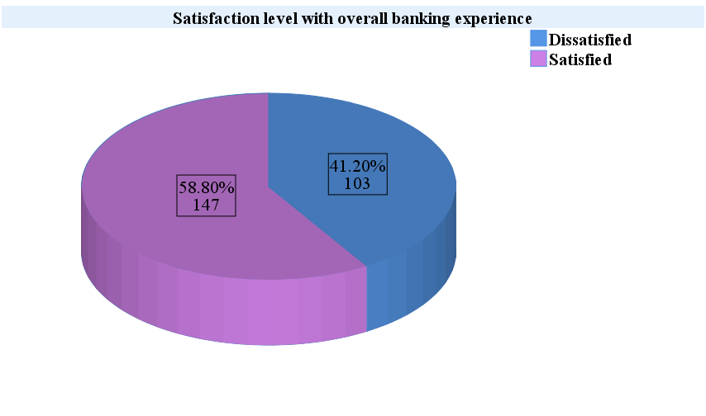
Fig-4.1.1: Pie chart of satisfaction level with overall banking experience

Fig-4.1.2 represents that there 194 male students with 77.60% and 56 female students with 22.40% out of 250 students who are included in the sample from University of Rajshahi.
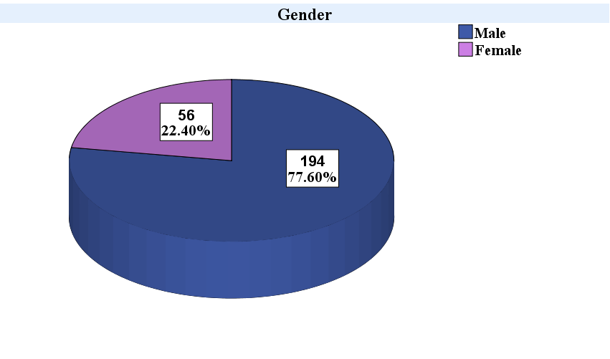
Fig-4.1.2: Pie chart of gender students
Fig-4.1.3 represents that most of the students who are included in the sample are from undergraduate level (219) with 87.6%.
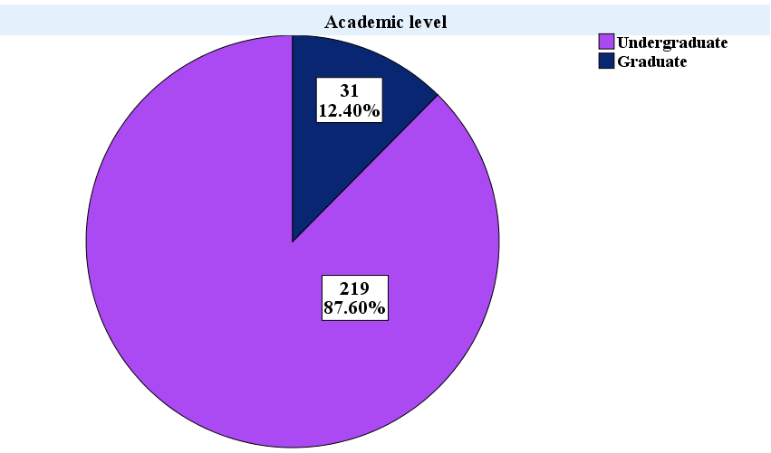
Fig-4.1.3: Pie chart of academic level of students

Fig-4.1.4 shows that 151 students with 60.40% from rural and 99 students with 39.60% from urban area among 250 students.
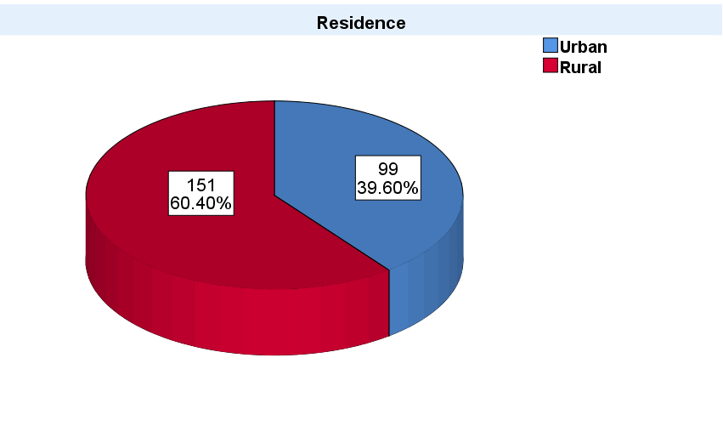
Fig-4.1.4: Pie chart of residency of students

Fig-4.1.5 presents the educational level of student’s parents. We observe that 14.8% of fathers and 16.8% of mothers have no formal education, 23.2% of fathers and 30.8% of mothers completed primary education, 26.4% of fathers and 30.4% of mothers reached secondary education, 15.2% of fathers and 14.4% of mothers attained higher secondary education, 10.0% of fathers and 4.8% of mothers earned a bachelor's degree, and 10.4% of fathers and 2.8% of mothers achieved this level of education.

Fig-4.1.5: Educational level of parents of the students

Fig-4.1.6 represents the occupation of student’s father and we can see that most of the fathers are farmers (100) with 40.0% whereas the least of the fathers are from services (40) with 160.%. There are 51 fathers with 20.4% who are businessman and rest 59 with 23.6% are from others occupation among the 250 fathers.
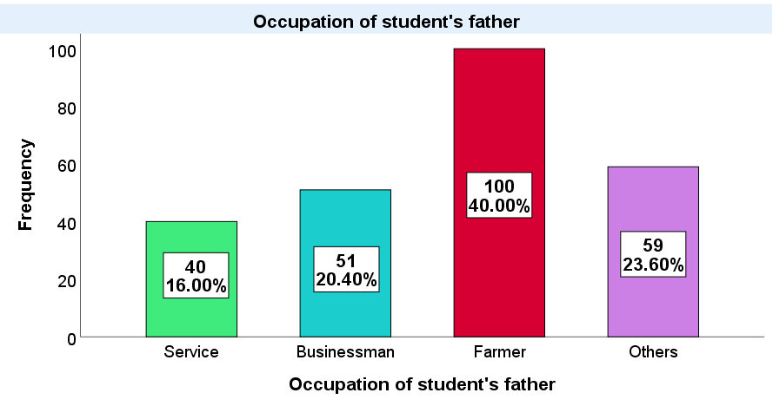
Fig-4.1.6: Bar chart of occupation of student’s father
Fig-4.1.7 shows that 127 users (50.8%) use mobile banking weekly, followed by 76 users (30.4%) monthly, 35 users (14%) daily, and 12 users (4.8%) rarely, indicating that weekly usage is the most common among users.
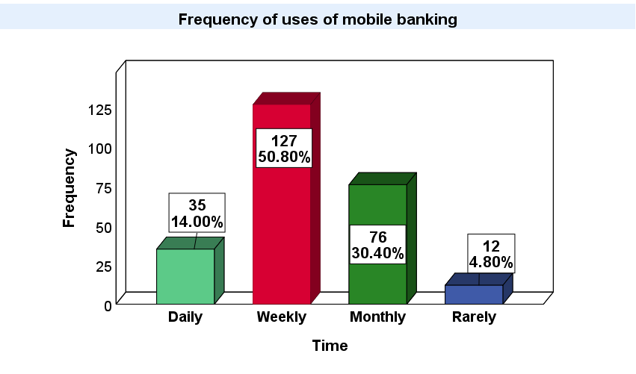
Fig-4.1.7: Bar chart of frequency of uses of mobile banking

Fig-4.1.8 represents that the majority of respondents 166 (66.40%) are somewhat confident in mobile banking security, while a smaller proportion is either very confident 50 (20.00%) or not confident 34 (13.60%).
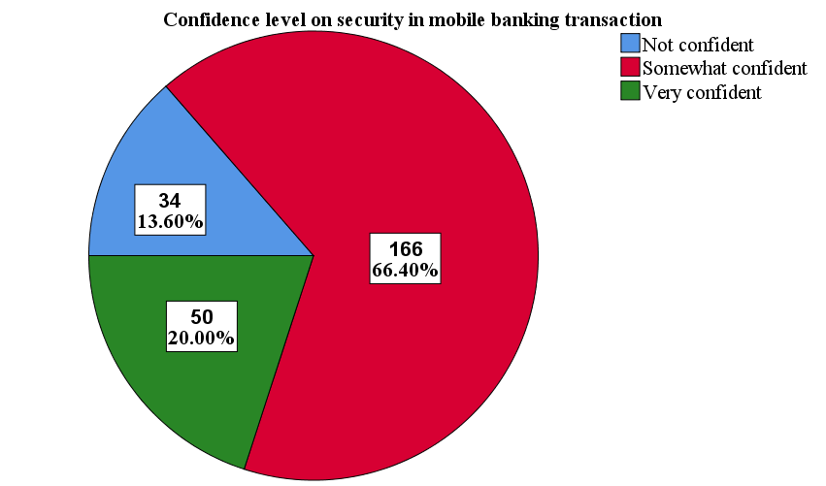
Fig-4.1.8: Pie chart of confidence level on security in mobile banking transactions
Fig-4.1.9 indicates that the majority of respondents, 169 students (67.6%) feel that the frequency of updates is just right. A smaller portion, 45 students (18.0%) believe that the updates are not frequent enough. Meanwhile, 36 students (14.4%) feel that the updates are too frequent. Overall, most respondents seem satisfied with the current update frequency.
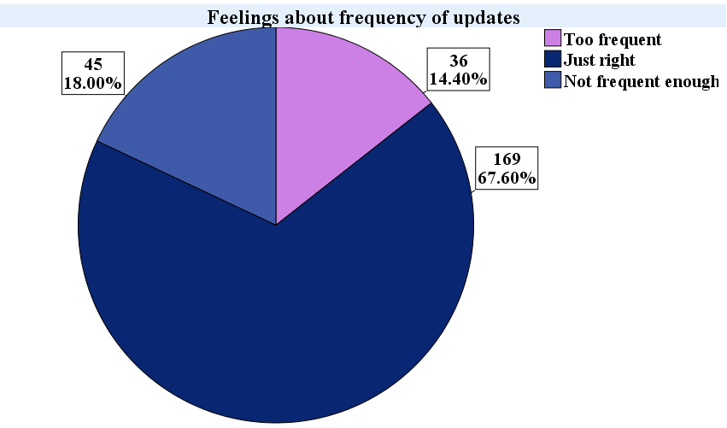
Fig-4.1.9: Pie chart of feelings about frequency of updates in banking apps

4.2 Association analysis
By the chi-square test, we have shown the association between the dependent and independent variables by the cross tables.
Table-4.2.1 presents the association between academic levels and satisfaction levels.
H₀: There is no association between academic level and satisfaction level with overall banking experience.
H₁: H₀ is not true.
Table-4.2.1: Association between academic level and satisfaction level
Variable | Group | Satisfied with banking |  | Chi-square  value | p-value
Variable | Group | No | Yes | Chi-square  value | p-value
Academic level | Undergraduate | 98 (44.7%) | 121 (55.3%) | 9.182 | 0.002
Academic level | Graduate | 5 (16.1%) | 26 (83.9%) | 9.182 | 0.002

Comment: We observe that our chi-square test value is 9.182 and p-value is 0.002 (<0.05). Thus, we may reject our null hypothesis at 5% level of significance. So, we may conclude that there is an association between academic level and satisfaction level with overall experience of mobile banking
Table-4.2.2 presents the association between family income and satisfaction levels.
H₀: There is no association between family income and satisfaction level with overall banking experience.
H₁: H₀ is not true.
Table-4.2.2: Association between family income and satisfaction level
Variable | Group | Satisfied with banking |  | Chi-square  value | p-value
Variable | Group | No | Yes | Chi-square  value | p-value
Family income | Less than 10000 | 32 (45.7%) | 38 (54.3%) | 0.947 | 0.814
Family income | 10000 to 15000 | 18 (40.9%) | 26 (59.1%) | 0.947 | 0.814
Family income | 15000 to 25000 | 23 (40.4%) | 34 (59.6%) | 0.947 | 0.814
Family income | Greater than 25000 | 30 (38.0%) | 49 (62.0%) | 0.947 | 0.814

Comment: We observe that our chi-square test value is 9.182 and p-value is 0.002 (<0.05). Thus, we may reject our null hypothesis at 5% level of significance. So, we may conclude that there is an association between academic level and satisfaction level with overall experience of mobile banking
Table-4.2.3 presents the association between monthly expenditure and satisfaction levels.
H₀: There is no association between monthly expenditure and satisfaction level with overall banking experience.
H₁: H₀ is not true.
Table-4.2.3: Association between monthly expenditure and satisfaction level
Variable | Group | Satisfied with banking |  | Chi-square  value | p-value
Variable | Group | No | Yes | Chi-square  value | p-value
Monthly expenditure | Less than 4000 | 21 (39.6%) | 32 (60.4%) | 0.314 | 0.957
Monthly expenditure | 40000 to 5000 | 40 (43.5%) | 52 (56.5%) | 0.314 | 0.957
Monthly expenditure | 5000 to 6000 | 20 (40.0%) | 30 (60.0%) | 0.314 | 0.957
Monthly expenditure | Greater than 6000 | 22 (40.0%) | 33 (60.0%) | 0.314 | 0.957

Comment: We observe that our chi-square test value is 0.314 and p-value is 0.957 (>0.05). Thus, we may not reject (accept) our null hypothesis at 5% level of significance. So, we may conclude that there is no association between monthly expenditure and satisfaction level with overall experience of mobile banking.

Table-4.2.4 presents the association between father’s education and satisfaction levels.
H₀: There is no association between monthly expenditure and satisfaction level with overall banking experience.
H₁: H₀ is not true.
Table-4.2.4: Association between father’s education and satisfaction level
Variable | Group | Satisfied with banking |  | Chi-square  value | p-value
Variable | Group | No | Yes | Chi-square  value | p-value
Father’s education | No education | 17 (45.9%) | 20 (54.1%) | 1.277 | 0.937
Father’s education | Primary | 25 (43.1%) | 33 (56.9%) | 1.277 | 0.937
Father’s education | Secondary | 27 (40.9%) | 39 (59.1%) | 1.277 | 0.937
Father’s education | Higher secondary | 14 (36.8%) | 24 (63.2%) | 1.277 | 0.937
Father’s education | Bachelor’s | 11 (44.0%) | 14 (56.0%) | 1.277 | 0.937
Father’s education | Master’s or higher | 9 (34.6%) | 17 (65.4%) | 1.277 | 0.937

Comment: We observe that our chi-square test value is 0.314 and p-value is 0.957 (>0.05). Thus, we may not reject (accept) our null hypothesis at 5% level of significance. So, we may conclude that there is no association between monthly expenditure and satisfaction level with overall experience of mobile banking.
Table 4.2.5 presents the association between father’s occupation and satisfaction levels.
H₀: There is no association between father’s occupation and satisfaction level with overall banking experience.
H₁: H₀ is not true.
Table-4.2.5: Association between father’s occupation and satisfaction level
Variable | Group | Satisfied with banking |  | Chi-square  value | p-value
Variable | Group | No | Yes | Chi-square  value | p-value
Father’s occupation | Service | 12 (30.0%) | 28 (70.0%) | 2.712 | 0.438
Father’s occupation | Businessman | 21 (41.2%) | 30 (58.8%) | 2.712 | 0.438
Father’s occupation | Farmer | 43 (43.0%) | 57 (57.0%) | 2.712 | 0.438
Father’s occupation | Others | 27 (45.8%) | 32 (54.2%) | 2.712 | 0.438

Comment: We observe that our chi-square test value is 2.712 and p-value is 0. (>0.05). Thus, we may not reject (accept) our null hypothesis at 5% level of significance. So, we may conclude that there is no association between a father’s occupation and satisfaction level with overall experience of mobile banking.
Table-4.2.6 presents the association between frequency of uses of mobile banking and satisfaction levels.
H₀: There is no association between frequency of uses of mobile banking and satisfaction level with overall banking experience.
H₁: H₀ is not true.
Table-4.2.6: Association between frequency of uses of mobile banking and satisfaction level
Variable | Group | Satisfied with banking |  | Chi-square  value | p-value
Variable | Group | No | Yes | Chi-square  value | p-value
Frequency of uses of mobile banking | Daily | 11 (31.4%) | 24 (68.6%) | 13.674 | 0.003
Frequency of uses of mobile banking | Weekly | 45 (35.4%) | 82 (64.6%) | 13.674 | 0.003
Frequency of uses of mobile banking | Monthly | 37 (48.7%) | 39 (51.3%) | 13.674 | 0.003
Frequency of uses of mobile banking | Rarely | 10 (83.3%) | 2 (16.7%) | 13.674 | 0.003

Comment: We observe that our chi-square test value is 13.674 and p-value is 0.003 (<0.05). Thus, we may reject our null hypothesis at 5% level of significance. So, we may conclude that there is association between the frequency of uses of mobile banking and satisfaction level with overall experience of mobile banking.

Table-4.2.7 presents the association between confidence level on security and satisfaction levels.
H₀: There is no association between confidence level on security and satisfaction level with overall banking experience.
H₁: H₀ is not true.
Table-4.2.7: Association between confidence level on security and satisfaction level
Variable | Group | Satisfied with banking |  | Chi-square  value | p-value
Variable | Group | No | Yes | Chi-square  value | p-value
Confidence level on security | Not confident | 24 (70.6%) | 10 (29.4%) | 21.407 | 0.000
Confidence level on security | Somewhat confident | 69 (41.6%) | 97 (58.4%) | 21.407 | 0.000
Confidence level on security | Very confident | 10 (20.0%) | 40 (80.0%) | 21.407 | 0.000

Comment: We observe that our chi-square test value is 21.407 and p-value is 0.000 (<0.05). Thus, we may reject our null hypothesis at 5% level of significance. So, we may conclude that there is an association between confidence level on security and satisfaction level with overall experience of mobile banking.
Table-4.2.8 presents the association between banking platform and satisfaction levels.
H₀: There is no association between banking platform and satisfaction level with overall banking experience.
H₁: H₀ is not true.
Table-4.2.8: Association between banking platform and satisfaction level
Variable | Group | Satisfied with banking |  | Chi-square  value | p-value
Variable | Group | No | Yes | Chi-square  value | p-value
Banking platform | bKash | 60 (41.7%) | 84 (58.3%) | 2.381 | 0.666
Banking platform | Nagad | 17 (35.4%) | 31 (64.6%) | 2.381 | 0.666
Banking platform | Rocket | 12 (54.5%) | 10 (45.5%) | 2.381 | 0.666
Banking platform | bKash, Nagad & Rocket | 11 (39.3%) | 17 (60.3%) | 2.381 | 0.666
Banking platform | Others | 3 (37.5%) | 5 (62.5%) | 2.381 | 0.666

Comment: We observe that our chi-square test value is 2.381 and p-value is 0.666 (>0.05). Thus, we may not reject (accept) our null hypothesis at 5% level of significance. So, we may conclude that there is no association between banking platform and satisfaction level with overall experience of mobile banking.
Table-4.2.9 presents the association between experience about customer care support and satisfaction levels.
H₀: There is no association between experience about customer care support and satisfaction level with overall banking experience.
H₁: H₀ is not true.
Table-4.2.9: Association between experience of customer care support and satisfaction level
Variable | Group | Satisfied with banking |  | Chi-square  value | p-value
Variable | Group | No | Yes | Chi-square  value | p-value
Experience in customer care support | Very dissatisfied | 1 (25.0) | 3 (75.0) | 36.714 | 0.000
Experience in customer care support | Dissatisfied | 4 (30.8) | 9 (69.2) | 36.714 | 0.000
Experience in customer care support | Neutral | 86 (55.8) | 68 (44.2) | 36.714 | 0.000
Experience in customer care support | Satisfied | 11 (15.3%) | 61 (84.7) | 36.714 | 0.000
Experience in customer care support | Very satisfied | 1 (14.3%) | 6 (85.7) | 36.714 | 0.000

Comment: We observe that our chi-square test value is 36.714 and p-value is 0.000 (<0.05). Thus, we may reject our null hypothesis at 5% level of significance. So, we may conclude that there is an association between experience about customer care support and satisfaction level with overall experience of mobile banking
Table-4.2.10 presents the association between speed of transaction and satisfaction levels.
H₀: There is no association between speed of transaction and satisfaction level with overall banking experience.
H₁: H₀ is not true.
Table-4.2.10: Association between transaction speed and satisfaction level
Variable | Group | Satisfied with banking |  | Chi-square  value | p-value
Variable | Group | No | Yes | Chi-square  value | p-value
Speed of transaction | Too slow | 2 (100.0%) | 0 (0.0%) | 15.250 | 0.004
Speed of transaction | Slow | 11 (57.9%) | 8 (42.1%) | 15.250 | 0.004
Speed of transaction | Acceptable | 63 (48.1%) | 68 (51.9%) | 15.250 | 0.004
Speed of transaction | Fast | 20 (28.6%) | 50 (71.4%) | 15.250 | 0.004
Speed of transaction | Very fast | 7 (25.0%) | 21 (75.0%) | 15.250 | 0.004

Comment: We observe that our chi-square test value is 15.250 and p-value is 0.004 (<0.05). Thus, we may reject our null hypothesis at 5% level of significance. So, we may conclude that there is association between speed of transaction and satisfaction level with overall experience of mobile banking.
Table-4.2.11 presents the association associated fees with mobile banking and satisfaction levels.
H₀: There is no association between associated fees with mobile banking and satisfaction level with overall banking experience.
H₁: H₀ is not true.
Table-4.2.11: Association between associated fees with mobile banking and satisfaction level

Variable | Group | Satisfied with banking |  | Chi-square  value | p-value
Variable | Group | No | Yes | Chi-square  value | p-value
Associated banking fees are reasonable | Yes | 37 (33.3%) | 74 (66.7%) | 2.790 | 0.095
Associated banking fees are reasonable | No | 66 (47.5%) | 73 (52.5%) | 2.790 | 0.095

Comment: We observe that our chi-square test value is 2.790 and p-value is 0.095 (>0.05). Thus, we may not reject (accept) our null hypothesis at 5% level of significance. So, we may conclude that there is no association between fees associated with mobile banking and satisfaction level with overall experience of mobile banking.

4.3 Binary logistic regression analysis
Table 4.3.1 present the results of examining factors associated with the satisfaction levels with overall mobile banking experience among students. The analysis includes adjusted odds ratios (OR) with 95% confidence intervals (CI) and p-values for various indicators. The Hosmer–Lemeshow goodness-of-fit test yielded a chi-squared value of 10.094 with a p-value of 0.258, indicating that the model was well-fitted to the data. The overall correct classification rate was 72.8%, and the area under the receiver operating characteristic (ROC) curve was 0.804. The ROC analysis indicates that the model has a good discriminative ability suggests that there is an 80.4% chance that the model will correctly distinguish between a randomly chosen positive instance and a randomly chosen negative instance. The model's sensitivity (76.2%) and specificity (68%) further support its effectiveness in predicting the outcomes. Graduate students are 4.1 times more likely to be satisfied compared to undergraduate students. The adjusted OR is 4.101 (CI: 0.079, 0.753, p = 0.014). Students who use mobile banking on a daily basis are 9.3 times more likely to be satisfied compared to students who use rarely. The adjusted OR is 9.350 (CI: 1.355, 64.539, p = 0.023). Students who use mobile banking weekly are 9.2 times more likely to be satisfied compared to students who use rarely. The adjusted OR is 9.242 (CI: 1.569, 54.442, p = 0.014). Students who are not confident on security with mobile banking are 7.2 times less likely to be satisfied compared to students who are very confident. The adjusted OR is 0.137 (CI: 0.043, 0.443, p =0.001). Students who are somewhat confident on security with mobile banking are 2.7 times less likely to be satisfied compared to students who are very confident. The adjusted OR is 0.366 (CI: 0.157, 0.851, p = 0.020).
Several factors are significantly associated with the satisfaction level on overall experience with mobile banking. Key factors include academic level, students who use mobile banking on daily and weekly basis and confidence level on security.
Table-4.3.1: The effect of academic level and different banking activities on satisfaction level with mobile banking
Variables | B | S.E. | p-value | OR | 95% C.I. for OR
 |  |  |  |  | Lower | Upper
Academic level
Graduate vs Undergraduate | 1.411 | 0.575 | 0.014 | 4.101 | 0.079 | 0.753
Frequency of use of mobile banking
Daily vs Rarely | 2.235 | 0.986 | 0.023 | 9.350 | 1.355 | 64.539
Weekly vs Rarely | 2.224 | 0.905 | 0.014 | 9.242 | 1.569 | 54.442
Monthly vs Rarely | 1.671 | 0.915 | 0.068 | 5.320 | 0.884 | 32.000
Confidence level on security
Not confident vs Very confident | -1.985 | 0.598 | 0.001 | 0.137 | 0.043 | 0.443
Somewhat confident vs Very confident | -1.006 | 0.431 | 0.020 | 0.366 | 0.157 | 0.851
Experience about customer care support
Very dissatisfied vs Very satisfied | 0.268 | 1.794 | 0.881 | 1.307 | 0.039 | 44.010
Dissatisfied vs Very satisfied | 0.554 | 1.415 | 0.696 | 1.740 | 0.109 | 27.870
Neutral vs Very satisfied | -1.252 | 1.216 | 0.303 | 0.286 | 0.026 | 3.099
Satisfied vs Very satisfied | 0.392 | 1.256 | 0.755 | 1.479 | 0.126 | 17.336
Rating on speed of the transaction
Too slow vs Very fast | -22.016 | 23022.07 | 0.999 | 0.000 | 0.000
Slow vs Very fast | -0.921 | 0.739 | 0.213 | 0.398 | 0.094 | 1.696
Acceptable vs Very fast | -0.372 | 0.540 | 0.492 | 0.690 | 0.239 | 1.989
Fast vs Very fast | 0.287 | 0.575 | 0.618 | 1.332 | 0.432 | 4.109
Constant | 1.560 | 1.586 | 0.325 | 4.761
Hosmer and Lemeshow test: Chi-square value = 10.094, p-value = 0.258

Fig-4.3.1 shows the ROC curve of the fitted binary model. The x-axis represents ‘1 – Specificity’, which is the false positive rate. The y-axis represents ‘Sensitivity’, which is the true positive rate. The curve rises steadily, indicating that as the false positive rate increases, the true positive rate also increases. The diagonal segments suggest ties in predicted probabilities at certain thresholds. The curve is closer to the top-left corner, which is a sign of reasonable classification accuracy.

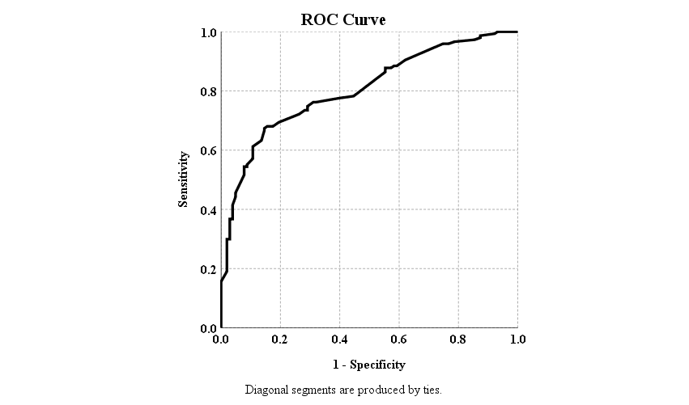
Fig-4.3.1: ROC curve

CHAPTER 5

Conclusion

5.1 Conclusion
In this study, we collected 250 data of students in University of Rajshahi. We established the frequency distribution of the students' personal details, including gender, family, residence, academic level, religion, monthly expenditure and family background, including the mother's and father's education and occupation and monthly family income.
From frequency analysis, we observed that there were 77.60% male, 22.40% female, 60.40% rural, 39.60% urban, 87.6% muslim, 11.6% hindu, 0.8% from other religion, 87.60% undergraduate, 12.40% graduate, 18.4% arts,32.4% science, 4.0% law,19.2% business studies, 8.4% social science, 2% agriculture, 9.2% engineering, 3.6% biological sciences, 1.6% veterinary and animal science,1.2% geosciences students respectively.
Next, we performed chi-square test and test the association among one outcome variable as satisfaction level with overall mobile banking experience and several independent variables, considered as all variables of personal details and banking information of the students. We found there was a significant association between academic level, frequency of use of mobile banking, confidence level on security, experience about customer care support, speed of transaction and satisfaction level with overall mobile banking experience and all variables are insignificant.
Finally, binary logistic regression analysis was performed. Binary logistic regression model showed that levels of the several independent variables are significant with respect to the reference category. Hosmer and Lemeshow tests showed that our selected model was good fitted.
In our study, among 250 students in University of Rajshahi, 147 (58.80%) students reported being satisfied with their overall banking experience and 103 (41.20%) students indicated dissatisfaction with their mobile banking experience.

5.2 Limitation
The limitation of the proposed study are as follows:
(i). We considered only students in our study
(ii). We only conduct the research study at University of Rajshahi.
(iii). Only students of University of Rajshahi were considered as sample in our study.
(iv). We considered only cross-sectional study.

5.3 Recommendation
The objective of our study was to test the satisfaction level of mobile banking among the students in University of Rajshahi. From analysis, we saw that there was a positive satisfaction level with mobile banking among the students in University of Rajshahi. Although students were positive about this topic, we should take necessary steps to increase more awareness about mobile banking in today's world.
Researcher should conduct this research study in a large part of population not the small part because they would provide more accurate information about the satisfaction level with mobile banking. Government as well as we should organize some program monthly or yearly about the benefits of mobile banking especially in students as well as all kinds of people in today's Bangladesh.
Therefore, hopefully, this study will be helpful for increasing the awareness and knowledge on mobile banking services.

Bibliography
Akter, R. (2023). A Study on Mobile Banking in Bangladesh. Cross Current International Journal of Economics, Management and Media Studies, 5(02), 39–43. https://doi.org/10.36344/ccijemms.2023.v05i02.005
Al-Husein, M., & Sadi, M. A. (2015). Preference on the Perception of Mobile Banking: A Saudi Arabian Perspective. European Online Journal of Natural and Social Sciences, 4(1), 161–172. http://www.european-science.com
Dahlberg, T., Guo, J., & Ondrus, J. (2015). A critical review of mobile payment research. Electronic Commerce Research and Applications, 14(5), 265–284. https://doi.org/10.1016/J.ELERAP.2015.07.006
Hai, M. A., & Rahman, M. M. (2016). Measuring the Satisfaction Levels of Mobile Financial Services Users in Bangladesh: An Empirical Study. Https://Services.Igi-Global.Com/Resolvedoi/Resolve.Aspx?Doi=10.4018/IJOM.2016010102, 6(1), 24–33. https://doi.org/10.4018/IJOM.2016010102
Islam, N., Ameen, M., Mustafi, A., Rahman, M. N., Nower, N., Mostafa, A., Rafi, M., Tasnim, N., Hassan, R., & Afrin, S. (2019). Factors Affecting Customers’ Experience in Mobile Banking of Bangladesh.
Kabir, M. R. (2013). Factors Influencing the Usage of Mobile Banking: Incident from a Developing Country. In World Review of Business Research (Vol. 3, Issue 3).
Kameswaran, V., & Muralidhar, S. H. (2019). Cash, digital payments and accessibility - A case study from India. In Proceedings of the ACM on Human-Computer Interaction (Vol. 3, Issue CSCW). Association for Computing Machinery. https://doi.org/10.1145/3359199
Santini, F. de O., Ladeira, W. J., Sampaio, C. H., & Boeira, J. P. (2020). The Effects of Sales Promotions on Mobile Banking a Cross-Cultural Study. Journal of Promotion Management, 26(3), 350–371. https://doi.org/10.1080/10496491.2019.1699622
Shaikh, A. A., & Karjaluoto, H. (2015). Mobile banking adoption: A literature review. Telematics and Informatics, 32(1), 129–142. https://doi.org/10.1016/J.TELE.2014.05.003
Singh, A. B. (2012). Mobile Banking Based Money Order for India Post: Feasible Model and Assessing Demand Potential. Procedia - Social and Behavioral Sciences, 37, 466–481. https://doi.org/10.1016/J.SBSPRO.2012.03.312
Zhou, T., Lu, Y., & Wang, B. (2010). Integrating TTF and UTAUT to explain mobile banking user adoption. Computers in Human Behavior, 26(4), 760–767. https://doi.org/10.1016/J.CHB.2010.01.013

Questionnaire for Research Project
Title: Exploring Mobile Banking Satisfaction Among Rajshahi University Students

Personal Details:
1.Contact No:
2.Gender : a) Male b) Female
3.Age : ……..…. years
4.Religion : a) Muslim b) Hindu c) Others
5. Faculty: a) Arts b) Science c) Law d) Business e) Social-science f) Agriculture
g) Engineering h) Biological sciences i) Veterinary & Animal Science j) Geosciences
k) Fine Arts l) Fisheries
6. Department :…………………..
7. Academic Level: a) Undergraduate b) Graduate
8. Residence: a) Urban b) Rural
9. District :………………………..
10.Father’s education: a) No education b) Primary c) Secondary d) Higher Secondary e)Bachelor’s f) Master’s or higher
11. Father’s occupation: a) Service b) Businessman c) Farmer d) Others
12.Mother’s education: a) No education b) Primary c) Secondary d) Higher Secondary e) Bachelor’s f) Master’s or higher
13. Mother’s occupation: a) Homemaker b) Teacher c) Health Professional d) Other Services e) Others
14.Family Income (monthly) : ………………….. TK
15. Do you have any income source? a) Yes b) No
16. If yes, what is your source of income as a student?
a) Tuition b) Part-time job c) Freelancing d) Online marketing e) Others
17. How much do you earn by yourself (monthly)?
- Please write-down:…………………..TK
18.Your monthly expenditure :……………………TK
Banking Information:
19. Which online banking platforms do you use?
a) bKash b) Nagad c) Rocket d) bKash, Nagad & Rocket e) Others
20. How frequently do you use online banking services?
a) Daily b) Weekly c) Monthly d) Rarely
21. Are you satisfied about overall experience with mobile banking.
a) Yes b) No
22. What features do you find most useful in the mobile banking apps you use?
a) Account management b) Security features c) Mobile Banking d) Customer support
e) Notifications and Alerts
23. How confident are you in the security of your online banking transactions?
a) Not confident b) Somewhat confident c) Very confident
24. What security measures do you think would enhance your confidence in online banking?
a) Multi-factor authentication b) Device recognition c) Automatic logout d) Biometric authentication
25. Have you ever contacted customer support for online banking issues?
a) Yes b) No
26. Rate the responsiveness and effectiveness of customer support.
a) Very Dissatisfied b) Dissatisfied c)Neutral d)Satisfied e)Very Satisfied
27. How do you feel about the frequency of updates and innovations in your online banking platform?
a) Too frequent b) Just right c)Not frequent enough
28. Rate the speed of transactions on your online banking platform.
a) Too slow b) Slow c) Acceptable d)fast e)Very fast
29. Would you recommend your banking platform to others?
a) Yes b) No
30. How easy is it for you to resolve issues or errors encountered during your online banking activities?
a) Very easy b) Easy c) Neutral d) Hard e) Very hard
31. Do you believe the fees associated with online banking services provide value for the benefits received?
a) Yes b) No
32.How satisfied are you with the overall cost-effectiveness of online banking?
a) Very dissatisfied b) Dissatisfied c) Neutral d) Satisfied e) Very satisfied
33. Do you find the educational resources provided by your online banking platform in understanding financial tools and features helpful?
a) Yes b) No
34.Would you like to see more educational content on using online banking services effectively?
a) Yes b) No
35.Have you tried online banking services from other providers, and if so, how does your current provider compare in terms of satisfaction?
a) Much more satisfactory b) Slightly more satisfactory c) About the same d) Slightly -less satisfactory e) Much less satisfactory

